GlobalBusiness_Partners Architecture

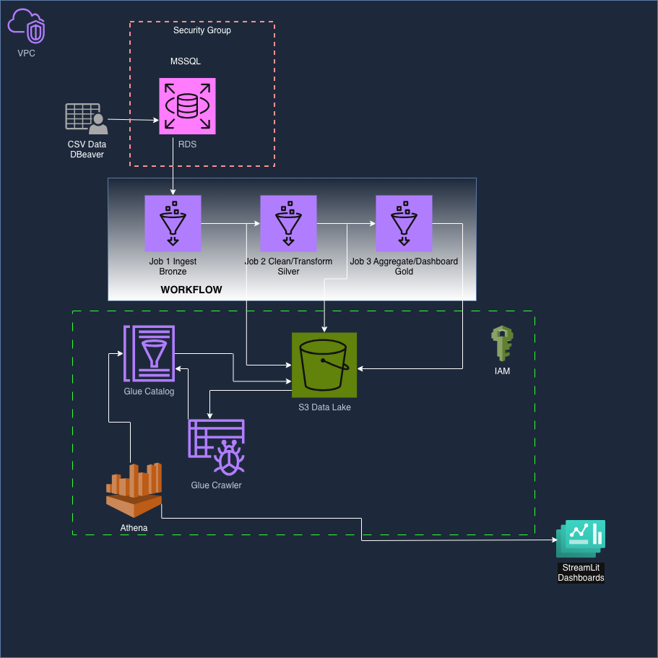
Setup/data loading phase(not part of the pipeline):
- CSV files are imported into Microsoft SQL Server hosted on AWS using DBeaver on Mac – per requirement to simulate pulling data from MSSQL server database.
Pipeline phase: RDS -> Bronze -> Silver -> Gold -> Athena
- Glue Job 1 is triggered manually and begins the workflow. Using Pyspark, this job ingests data from RDS as is for Bronze. This layer preserves raw structure, no joins yet.
- Glue Job 2 using Pyspark, cleans data from Bronze to Silver layer. This is where data quality issues get addressed. This data will be converted to parquet for faster and cheaper queries downstream, pushed to S3.
- Glue Job 3 using Pyspark, will run after successful silver layer run. In this layer, table joins will happen and data becomes analytics-ready, also converted to Parquet, pushed to S3. In this layer, we determine what we will partition the data by for dashboard readiness.
- Glue catalog holds metadata from gold layer in S3. Glue crawler will put gold layer in glue catalog as metadata, detecting parquet format. This allows table to immediately appear in Athena so queries can be run directly on S3 files. Why Glue Crawler?
  - Glue crawler automatically detects partitions in S3 data
  - Great for incremental updates, instead of scanning everything.
  - Automated schema discovery from different formats such as json, csv, parquet and determines column names and data types.
* For simplicity of project, we will only place one crawler for gold layer.
Dashboards – Local
- Streamlit is installed locally and connects to Athena to gather gold data with Python script.
*Incoming port 1433 for MSSQL RDS must be open in security group to get data to Bronze layer and 1433 must be open to IP address on mac or open to internet to connect DBeaver to RDS
* IAM role must be configured to allow glue, Athena and S3 to interact with each other.
Data Model:
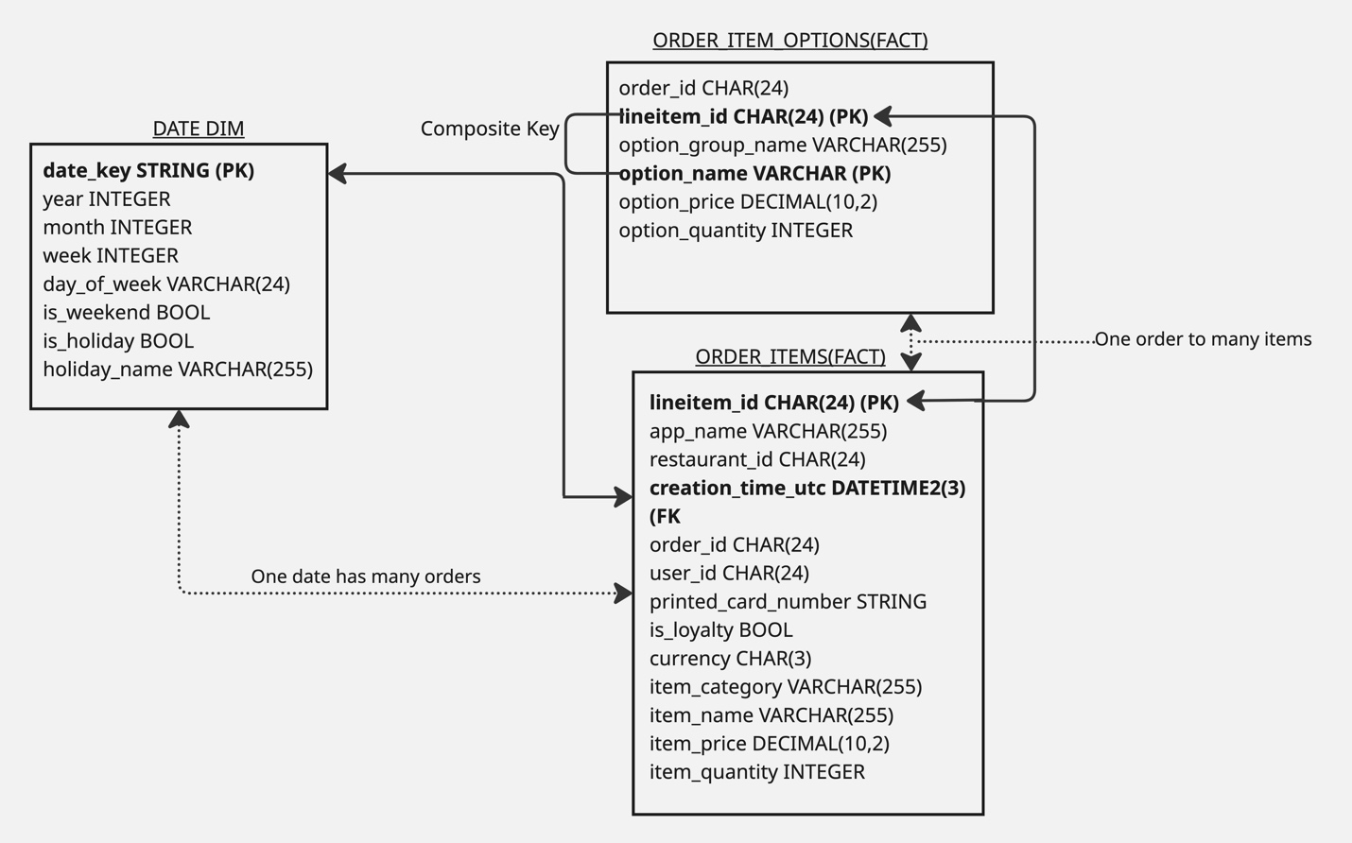
Bronze Layer Loading;
- Created initial data connection for this job and all subsequent jobs to pull data from RDS. Credentials, database URL and password are stored securely in jdbc_conf and script extracts from it.
- Ingestion scripts loops through table names from MSSQL and loads into bronze bucket in S3 as parquet files.
Silver Layer Transformation:
Here are the columns and data issues we need to address in silver layer:

Date_dim:
TRANSFORMATION | WHY | SOURCE VALUE | TARGET VALUE
Date_key to date format  *UPDATE – Created a 2023 calendar instead | Currently a string, needs to be a real date | String | DATE
Date_Key IS NULL | PK can’t have null values | NULL | Remove Nulls
Is_holiday/is_weekend | Need to be actual true or false | String | Boolean
Year/month,week | Verify correct format | Integer | Integer(verify)

Order_items:
TRANSFORMATION | WHY | SOURCE VALUE | TARGET VALUE
Lineitem_id | PK should have no null values | Null | Drop nulls
Is_loyalty | Should be true or false Boolean | String | boolean
Creation_time_utc | Needs to be timestamp type | String | DateTime2(3), change to creation_date with just date to join with date_dim
creation_date | To match date in dim | timestamp | DATE

Order_item_options:
  - Only dropping duplicates.
Discoveries:
- Date_dim, only has year 2023 while order_items goes from 2020-2024. For the scope of this project, I have filtered in silver layer for just year 2023. Other options could be to scope out remaining years and holidays for future joins.
- In order_item_options, after creating composite key of lineitem_id, option_group_name, and option_name, we still ended up with over 2k duplicates. These have been dropped in silver layer.
- Since we are only using year 2023, this leaves many orphaned lineitem_ids in order_item_options because there is no longer any 2020 and 2024 to point to. For now we are going to do a left join in gold layer to only get the usuable data.
- In order_items, the user_id has many duplicates that are being dropped for the sake of this project. CLV will be calculated only with the users that we can identify.
- After running some tests on gold layer, I discovered that there were many null values for dates, specifically in date_dim. Upon further investigation, there are only 145 distinct date keys in date_dim with a 221 gap. Looking back at the raw data for date_dim, I discovered the date formats are not all being converted properly using pyspark ‘to_date’ function. The best course of action to avoid over complicating it ,is to create a whole 2023 calendar for the date_key so it will always be correct.
- With this in mind, the is_holiday will be set to false for now unless downstream queries require it, then we will have to populate proper holidays for 2023 year since the raw data is unreliable
- I have just discovered why production data warehouses never trust source date dimensions. They generate them in code. Source data has formatting bugs that are nearly impossible to clean comprehensively, but a simple calendar is easy to generate.
- After running queries with Athena on gold table, I discovered that total revenue is wrong since there are multiple line items with order options, that aren’t included. Instead of having analysts write complex subqueries or windows functions, I updated my gold table to group the order_item_options table by lineitem_id and aggregate to get count of options and sum of option_prices and option_quantity. Then created 3 more columns to table after joining to show item_revenue, option_revenue, then total_line_revenue (item_revenue + option_revenue). Now dashboard queries will be much simpler to write since we know the true amont spent with items and options.

